IBM Training Day -3

Q1. wap to input a number and print the sum of its digit.

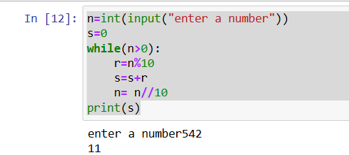

Q2.wap a program to input a number and find wheather it is amstrong or not.

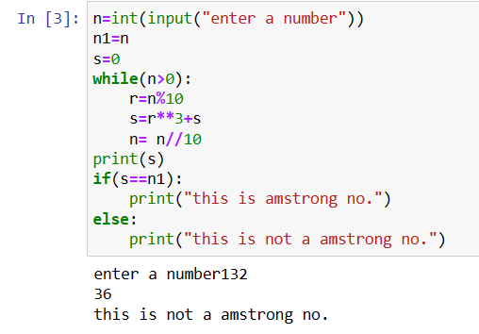

Amstrong no= the sum of cube of digit is equal to the original no.

Q3.wap to input a number and check whether it is palindrome or not.

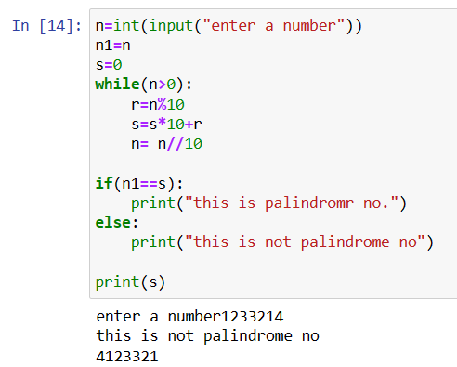

Q4. write a program to input a no. and find it is prime or not.

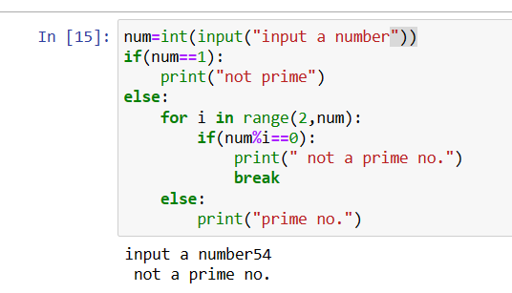

Q1. wap to print prime no, from 15 to 30.

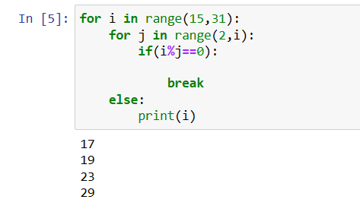

Q2.wap to print multiplication table of all the numbers fron 1 to 10.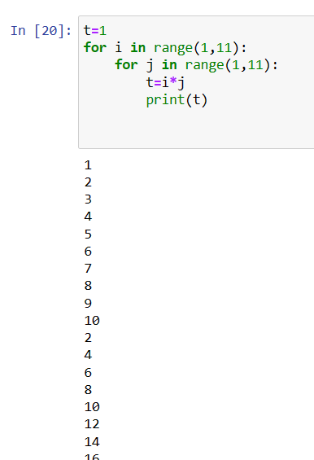

Q3.print the following pattern

\*

\* \*

\* \* \*

\* \* \* \*

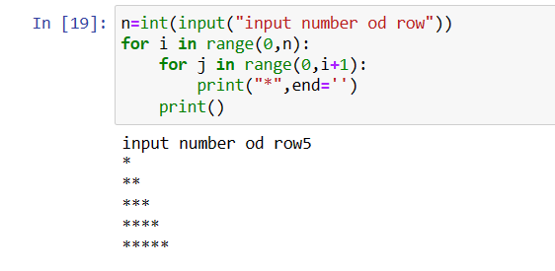

Q4. Wap for pattern

1

12

123

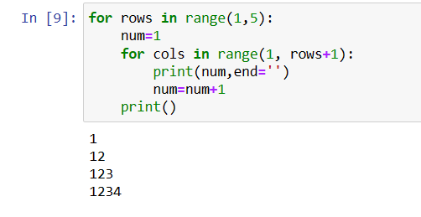

Q5.wap for pattern

A

AB

ABC

ABCD

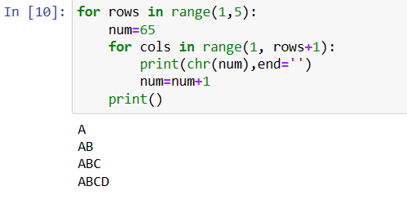

Q1.wap a program to input a string and count the number of letters, digits znd special charcters in a string.

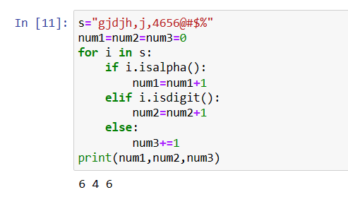

Q2.WAP to input a string and count the number of uppercase and lowercase letter.

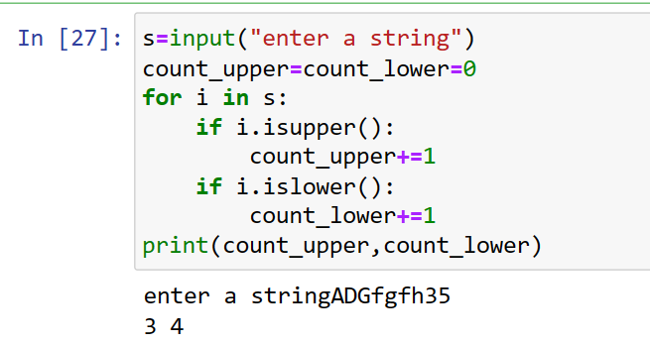

Q2.WAP to get a string made of the first two and last two charecter of a given string

if the string length is less than 2, return the empty string instead.

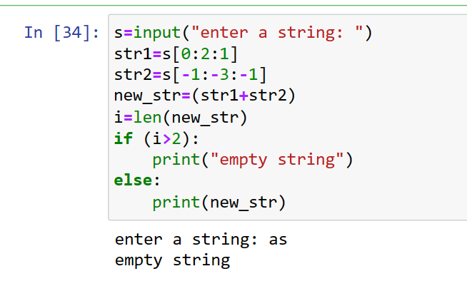

Q3.WAP to remove character that have odd index values in a given string.